**SEVENADVANCEDACADEMY**

**Basic HTML & Git Assignment**

Home Work

Total Marks: 100

Instructor: Mr. Modest Wilton

# Part A: Multiple Choice Questions (20 marks)

Choose the correct answer for each question.

1. What does HTML stand for?

* a) Hyper Text Markup Language
* b) High Text Making Language
* c) Hyper Text Making Language
* d) None of above

1. Which tag is used for the largest heading?

* a) <heading1>
* b) <h6>
* c) <h1> ● d) <head>

1. CSS stands for:

* a) Cascading Style Sheets
* b) Computer Style Sheets
* c) Creative Style System
* d) Color Style Sheets

1. Which git command creates a new repository?

* a) git init
* b) git start
* c) git begin
* d) git new

1. To clone a repository, we use:

* a) git clone
* b) git copy
* c) git download
* d) git pull

# Part B: Structural Questions (30 marks)

Answer the following questions:

* Write the basic structure of an HTML page. (6 marks)

<!DOCTYPE html>

<html >

<head>

<meta charset= ‘’UTF-8‘’>

</head>

<body>

</body>

</hmtl>

* What is the difference between an HTML tag and element? (6 marks)

*-Html tags are made up of angle brackets that surrounds it and it is made up of two categories i.e. (opening & closing tags and self closing tags)*

*-while elements are designators that are used to define the structure and content of objects in a web page, if we view and html page like the skeleton of a body and the css as the style and good looking appearance therefore elements contribute in given good forms to that skeleton*

* List three basic CSS selectors we learned. (6 marks)

*-id (i.e. #id_name{})*

*-class (i.e. .class_name{})*

*-type (h1{}, body{}, p{})*

* What is the purpose of git add command? (6 marks)

*Its role is to keep track of a Project progression and makes the project works to be ready for commitment (git commit –m ‘’) each time we are working on a project and that we check the status it will indicate the changes that need to be saved and that is the (git add) command comes in for proper usage we usually use the syntax: (git add .) to specify all files and that is the recommende way to do that*

* Explain what a CSS property and value is with an example. (6 marks)

Answer:

*Body{*

*Background-color : #f1f1f1;*

*}*

*-Body is the selector that select the portion of the body*

*-background-color is the property that specify which style is to be applied on the body*

*-#f1f1f1 is the value and it is used to set a specific color to the background*

*Of the body*

# Part C: Practical (50 marks)

Complete the following tasks:

* Git Tasks: (20 marks)
* Create a new repository
* Clone it to your computer
* Create a development branch

HTML Requirements: (15 marks) ● Create index.html with:

<!DOCTYPE html>

<html>

<head>

<title>My First Page</title>

<link rel="stylesheet" href="style.css">

</head>

<body>

<h1>Welcome</h1>

<h2>This is my first webpage</h2>

<p>This is a paragraph.</p>

</body>

</html>

●

CSS Requirements: (15 marks)

* Create style.css and:
* Change text color
* Change background color
* Style your heading

**Grading Criteria:**

* Multiple Choice Questions: 20%
* Structural Questions: 30%
* Practical Implementation: 50%

**Submission:**

* Submit your GitHub repository link

https://github.com/axel-fz/homework1_html_basics.git

* Take screenshots of your completed tasks

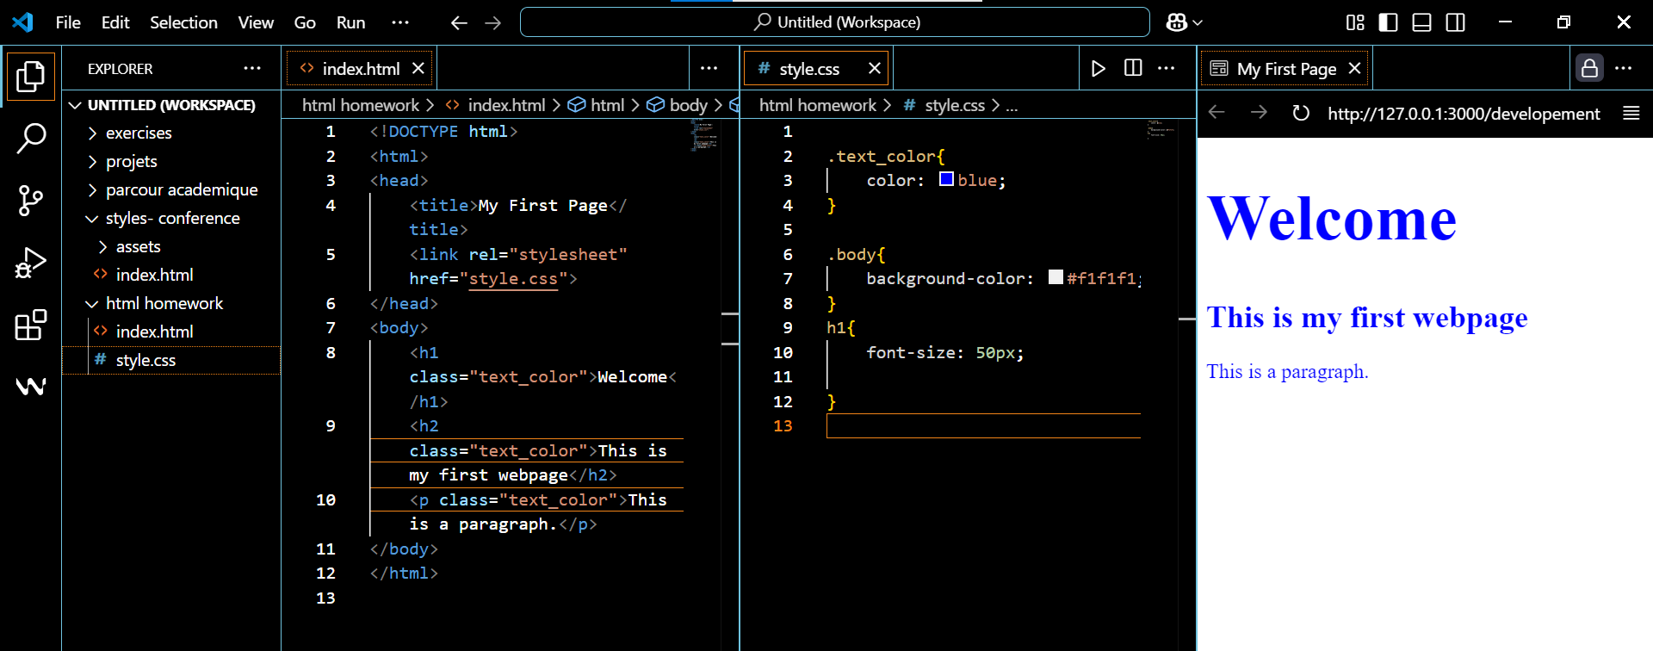

Good Luck!

SEVEN ADVANCED ACADEMY © 2024